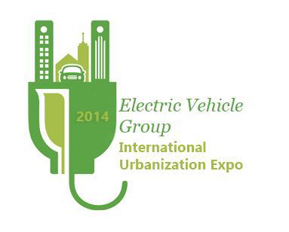

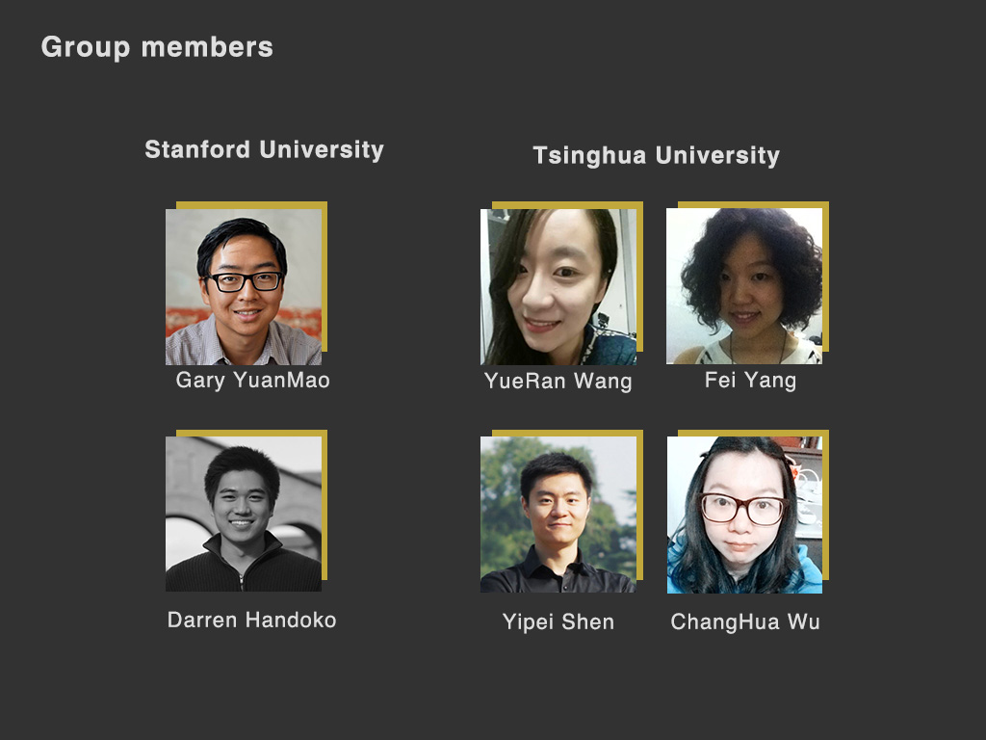

CHINA – TSINGHUA | BAY AREA - STANFORD
The Electric Vehicles team is a diverse mix of students from Tsinghua University and Stanford University with backgrounds in business, engineering, and design. Talents range from 3D printing and design, graphic design, business strategy, and construction. Language alternated between Mandarin and English through the medium of Skype and WeChat.

Electric vehicles have become an increasingly important topic of discussion in cities all across the world. As urban landscapes become more polluted, populated, and pricey, electric vehicles have emerged as a solution for many consumers. In the Bay Area and China, issues of air pollution, transportation, and environmental quality have pushed the agenda of increasing EV adoption to the forefront. By helping to diversify the fuel mix, electric vehicles reduce dependence on petroleum and tap into a source of electricity that is often domestic and relatively inexpensive. As cities seek to clear urban skies, EVs will play an important role in reducing tailpipe emissions.

The benefits of electric vehicles are well documented and well understood. Yet, EV adoption has been lukewarm at best. The Electric Vehicles team set out to answer the following questions:

With so many incentives and benefits for electric vehicle promotion, why haven’t electric vehicles taken off?

What technological, environmental, political, and social issues do electric vehicles face?

How have electric vehicles in China fared compared to the Bay Area?

This report showcases our results to these fundamental questions. The China team and the Bay Area team each tackled a different portion of the electric vehicle challenge and presented solutions in different forms and media, from a 3D printed bike to a prototype of a phone application. As a group, we really enjoyed the opportunity to work together and participate on a truly exciting topic. Enjoy!

STANFORD UNIVERSITY – INITIAL RESEARCH
Surveying

For the US part of our study we choose to investigate Santana Row located in San Jose. Opened on November 7, 2012, Santana Row is a Mediterranean influenced mixed-use promenade with over 20 restaurants, 70 retail stores, 403 rental apartments, 219 condominiums, and a 65,000 sq ft office space. It runs about a straight quarter mile south of Westfield Valley Fair Shopping Mall, the primary shopping mall in Santa Clara County.

We choose this location for several reasons: 1. Symmetry with the China team who choose a high foot traffic mixed-use zone in Beijing, 2. Many different options to get there (e.g., bus, car, bike, etc.), and 3. A tesla dealership was located there.

We choose to visit this location on Saturday 10/25 to best capture the location on a day to see what the area will look like at low activity (before 10am) and maximum activity (noon – 6:00pm). To get there (from Cupertino and from Palo Alto) we decided to carpool to minimize the need to find parking in the area which can often be a challenge on weekends. Below is a table of how much time it would take to get there given different transportation systems from Cupertino (Apple HQ) and Palo Alto (Stanford University)

Source: Google | Bike | Bus | Drive
Stanford | 28 min | 50 min | 10 min
Cupertino | 1 hr 24 min | 1 hr 50 min | 22 min

While on the site we planned to do four major forms of observation:

1. Representative Survey on Transportation Preferences
2. “Arrogance of Space” Analysis at major road sections
3. Passive observations of the space
4. Expert Interviews

Passive Analysis of Santana Row

The area has since it’s opening been an interesting part of South Bay lore. Located across the street south of Westfield: Valley Fair, the quarter mile stretch took up what was once a Chevrolet dealership along Stevens Creek Blvd. which was mostly known for the Auto Mall there and Valley Fair. Most of the retail space in the area other than Santana Row was from the 1950s-60s. If you go a half-mile east or west of Santana Row residential properties start to price at 400k-600k versus the $1.5 million just next door. In other words Santana Row certainly stands out in different ways to different sets of people. The word “artificial” oftentimes comes up in regards to that space given there is nothing that looks like it even if you went 5 miles East or West of it on Stevens Creek.

Walking inside just off of the main road Stevens Creek you already see a very different environment from the main street you turn off. 3-4 lane roads transform into 1-2 with LED lit pedestrian crossing signals, expensive cars lined on either side and palm trees running down the center divider reminiscent of Palm Drive at Stanford. As you look up you see pastel colored buildings with iron railed balconies where residents can people watch the shoppers below. It is very much meant to look like a European promenade in the middle of America suburbia. The brands also are very telling of the space. While there are plenty of Ferraris, Porsches, and of course Teslas to be seen, the retail stores are not of the Louis Vuitton, Gucci, and Chanel variety (that is located in a recently constructed extension of Westfield: Valley Fair, but rather of lesser known, but still successful boutiques blended with the usual suspects of H&M, Urban Outfitters, and Brooks Brothers.

The sounds are also unique to the quarter-mile two main highlights: outdoor live music and the roar of supercar engines. With three very clean and curated park sections you can book these areas to hold various events from piano recitals to famous acts performing. Nearly every weekend there is someone performing and if nothing is booked there are hired musicians. The extent in which music impacts the space is even more apparent given a more traditional suburban mall is just across the street where one of the hallmarks of suburbia, the echoing ring of top 40s with intermittent announcements of sales. But in Santana Row instead of intermittent sale announcements the intermittent noise is the sound of someone in a $100k+ car reving his engine out of the Hotel Valencia under the posted speed limit of 17 mph. During our visit there on 10/25 the live music was a local youth orchestra and the revs came from a red Ferrari.

In surveying the people there the general age of those we found just purveying the streets skewed almost 75% above the age of 30. Within this group there were two distinct classes of individuals, those who walked and patron the sidewalks and those who were in the middle divider or other park sections. Those who where in the open space sections were more heavily skewed families many of which had kids playing in the open space. Along the sides it dends to skew on the younger end of the demographic, designer dressed individuals who were also the same people that were in the more boutique stores and in the bars and bistros. Thus there are some who clearly come to spend their money and others use the space the same as a public park. Additionally the overall structure of the area appeared mostly designed to be a quick in and out experience as opposed to an insular and livable space. With a little over 600 residential units those who live in Santana Row pale in number to the 12 million annual visitors

In regards to the transportation layout of Santana Row the design was designed for the driver in mind. First of all the location (as is the mall that is north of it) is not connected to Caltrain or VTA Light rail. Second in observing the layout of the road, while there is ample walkway/crosswalks for pedestrians there are no designated bike lanes inside the row and bikers often times ride along the outside perimeter of the area, locking their bikes up in a garage or on designated bike racks out of viewing distance from the main strip. In the time we visited the site for our observations and in previous visits we have never come across bicycles on the main strip other than deliberate window displays that used bicycles.

Survey Questions
Age?
Gender?
Living Situation?
What forms of transportation do you take to work?
How long is your daily commute?
How far is your commute?
What car characteristics are most important to you?
Are any of your transportation types electric?
What forms of transportation did you take to Santana Row?

Survey Results

While people are different we also learned to not only prepare a well designed survey, but to also be more prepared in our pitch to strangers. We found that by fine tuning an elevator pitch we could not only hasten the interaction, but it also increased our success rate. Specifically, we learned that by opening with who we are and what we are doing, asking for peoples time on a survey became much easier. Our response rate improved from about 1/5 to almost ½.

Given the questions we were asking and the pre-work we did on understanding the space. I would say that we did a pretty good job at accomplishing the field work we set out to do. The main critique I would say would have been worth exploring in the future was to be more deliberate at getting a balanced view from both genders (our survey of randomly walking around wound up being ¼ women, ¾ men). One reason is because it would have allowed us to explore a different dimension of how demographic can impact some of the responses we received. Additionally there was some biases that may have come from the places in which we approached people (the outdoors, people who were sitting down, looking not busy). This approach meant that we did not go into the stores specifically to stop people mid-shopping.

The following are some key results of the survey:

TSINGHUA UNIVERSITY – INITIAL RESEARCH
On the Tsinghua side, the China team went out to survey a high foot traffic zone in Beijing. The following survey was given:

- 您的年龄是：Your Age
□<23 □24-28 □29-35 □36-40 □>40

- 您的性别是：your Gender
□男/men □女/women

- 您目前住宿的情况是：Accommodation status:
□租房/Rent □已购房/own □借住他人/share □其他____/others

- 您目前采取何种交通工具上下班（可多选）：/what is your transportation tool for work
(you can have multi check)
□步行/walk □自行车/bicycle □电动滑板或自平衡车/Electric Skateboard
□电动车（两轮）/Electric Motor cycle (two wheels) □公交/bus □地铁/sub way □开车/drive □搭出租车/Taxi □搭顺风车/Car pool □其他____/others

- 您目前上下班需要的时间是：/How long to take from home to office
□15分钟之内/less 15 minutes □15-30分钟/minutes □31-60分钟/minutes
□1-1.5小时/hour □2小时以上/two hours or more

- 您目前上下班的里程是（单程）：/what is mileage between house and office (one way)
□5公里以内/less five kilometer □6-10公里/kilometer □11-15公里/kilometer
□16-20公里/kilometer □20公里以上/ 20 kilometer or more.

- 您期望的电动车价格区间为：/what is expected prices for electric motor cycle
□1000元以下/less 1000 Yun □1000-2000元/Yun □2001-3000元/Yun
□3001-4000元/Yun □4001-5000元/Yun □5000元以上/above 5000 Yun

- (若有)您现在的电动车（两轮类）价格是：what is the price you pay (If you have) for
Electric motor cycle (two wheels)
□1000元以下/less 1000 Yun □1000-2000元/Yun □2001-3000元/Yun
□3001-4000元/Yun □4001-5000元/Yun □5000元以上/Above5000 Yun

- （若有）您现在的电动车（两轮类）的充电方式是：/what is the way you charge your
Electric motor cycle (if you have one)
□拎电池入室/Carry battery to room □甩线是充电/Pull electric wire out
□地下室或一层充电/basemen power code charge.

- 您最看重电动车的下列哪些特点（可多选）：What are most important feature you prefer (can have multi check)
□安全性/safety □续航里程/mileage per charge □载人、载物/Carry people and things
□造型/good looking □方便停车/easy parking □不易丢失/not easy been theft
□速度/speedy □维修/maintenances □其他____/others

Survey Results

Age | 小计 | 比例
23岁以下 | 12 | 10.08%
24~28 | 61 | 51.26%
29~35 | 35 | 29.41%
36~40 | 7 | 5.88%
40以上 | 4 | 3.36%
本题有效填写人次 | 119

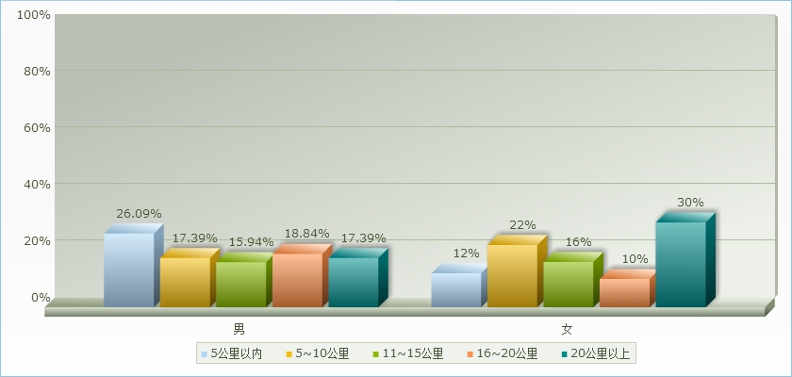
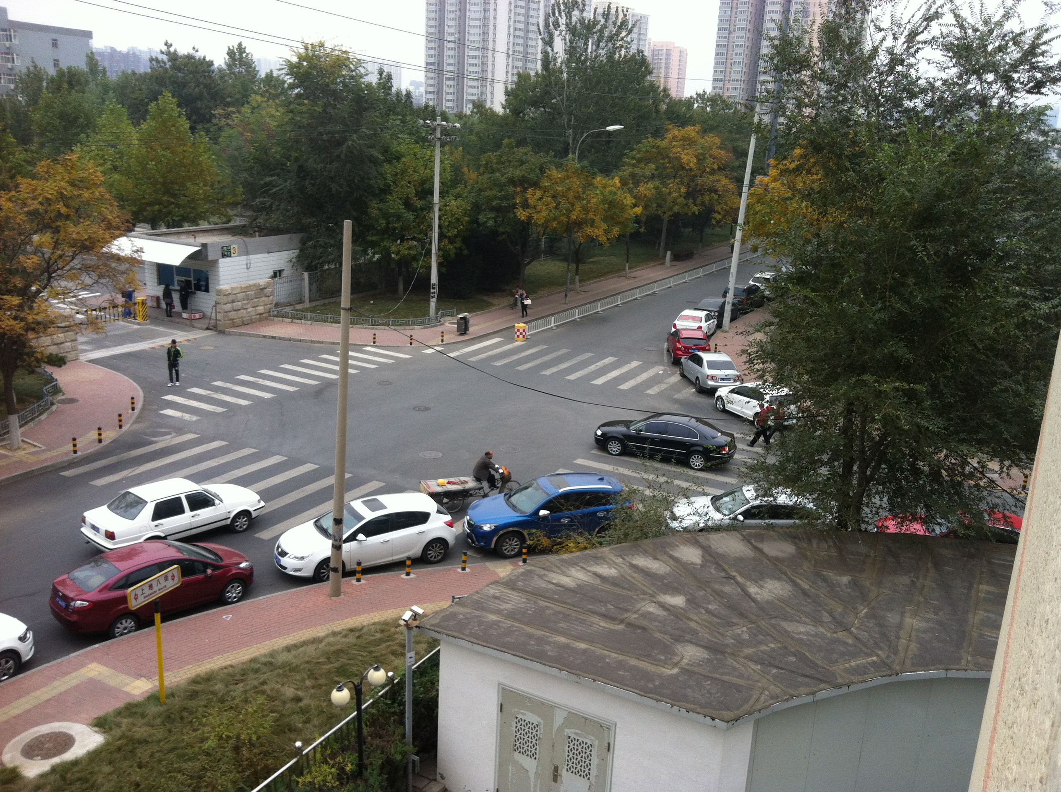
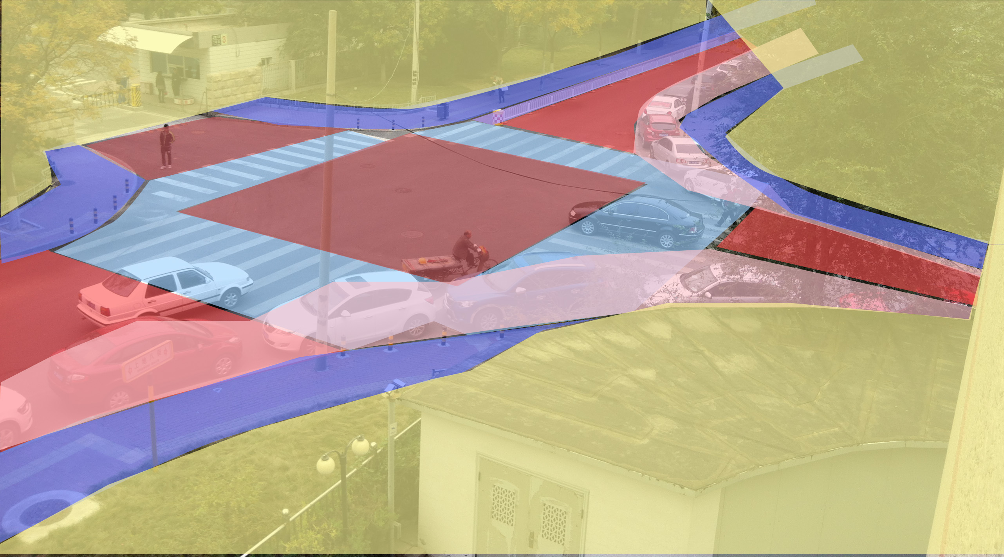

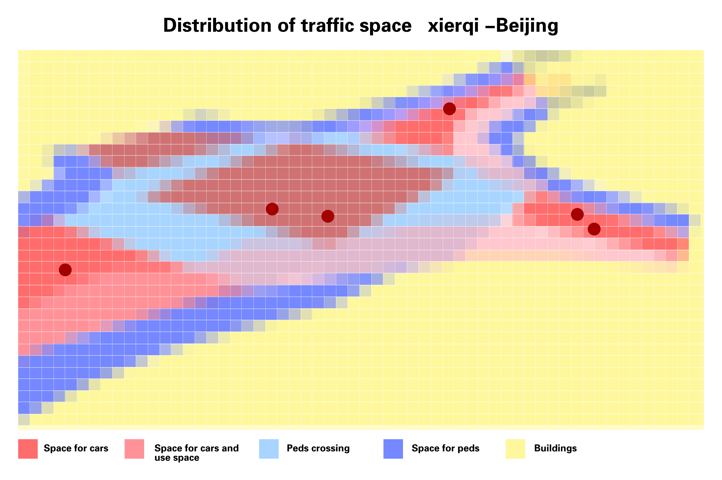
Expert Interview
The Tsinghua team interviewed an expert in China who has studied the transportation and population problem in China. A few key results emerged from this expert interview, illustrated on the infographic below:
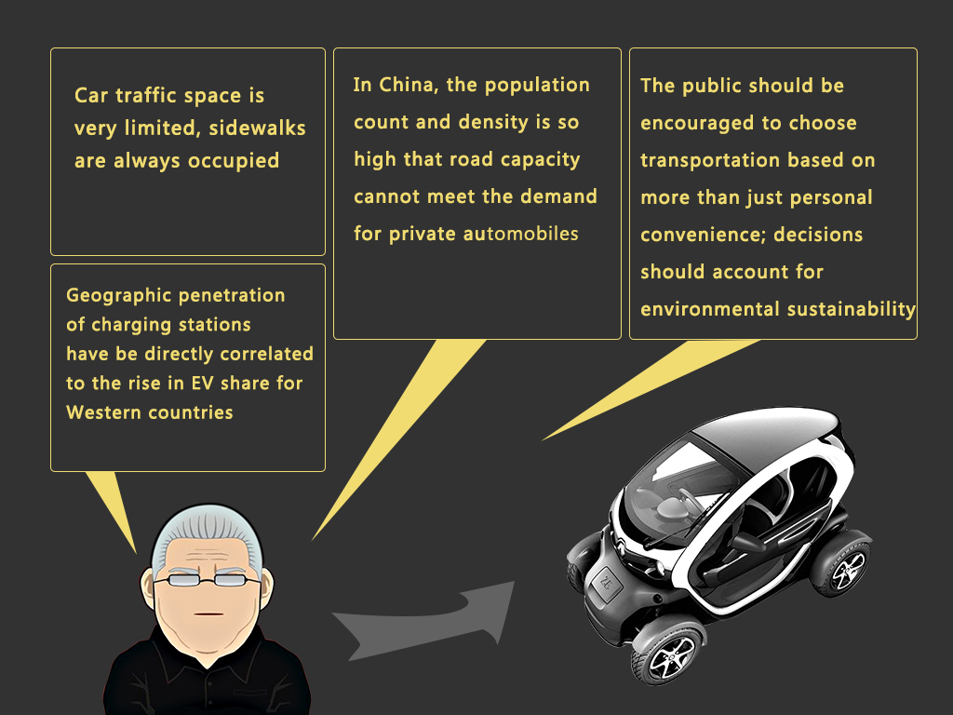

STANFORD UNIVERSITY – PROTOTYPING
After a month of the process of running between conducting a city study, and syncing up with other team members it was time for us to start gathering up our data and preparing to prototype. Based on the exercises we did during labs and additional meeting outside of it with the China team the first step was to see the major themes that came out of it. We decided to focus on two major themes: 1. Finding a way to solve the annoyance of EV bike charging, 2. Finding a way to give greater transparency to comparing different transportation options. Over the course of prototyping we explored building physical models, user testing, pen and paper wireframes and app prototyping.

TravelIQ App – Santana Row and Cupertino

The TravelIQ App is an app that lets users measure the full cost of taking different modes of transportation. We went to Santana Row, Valley Fair Shopping Center, and Cupertino Square to seek out 100 survey respondents to test out a pen and paper storyboard and ask four fixed questions.

In the first iteration, we tested for the following points:
- Is this service useful at all for people?
- Are my high level designs capable of telling the story of the service?
- What major features am I missing?
The Positive
- What got people excited about the idea? – Many respondents started that they never noticed before that they did not considered the whole of their transportation options and it intrigued them that car wasn’t always the definitive best option. For some they commented if it could help them get to things on time that would be a great advantage given that cars can sometimes get into traffic jams and thus lose the initial appeal of convenience that cars give.
- What did people value the most? – People seemed to value most the potential to have the simplicity to have the app give a single metric for which transportation option is better. Another common response that should be considered in the future is the accuracy of these estimations. Since the product relies on computer calculated time to destination it may not always be reflective of real time traffic or other unforeseen delays.
- What did people remember positively? – People remembered the simplicity of what we were trying to make. Though not everyone got it right away when they did a commonly comment that if we can make it work within 4 screens it could be something they would entertain using. Another aspect people commented on was the social good that we were trying to do. While many did not necessarily have EV vehicles in their purchasing horizon, people often commented on the fact that young people doing good things was an inspiring thing to see.
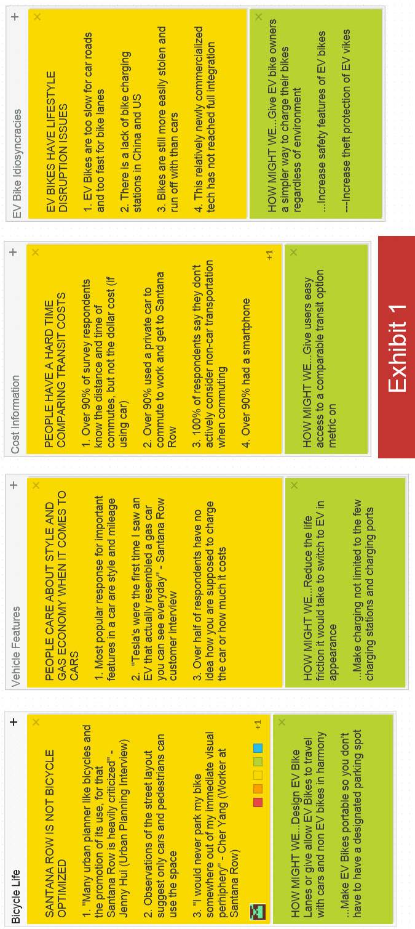
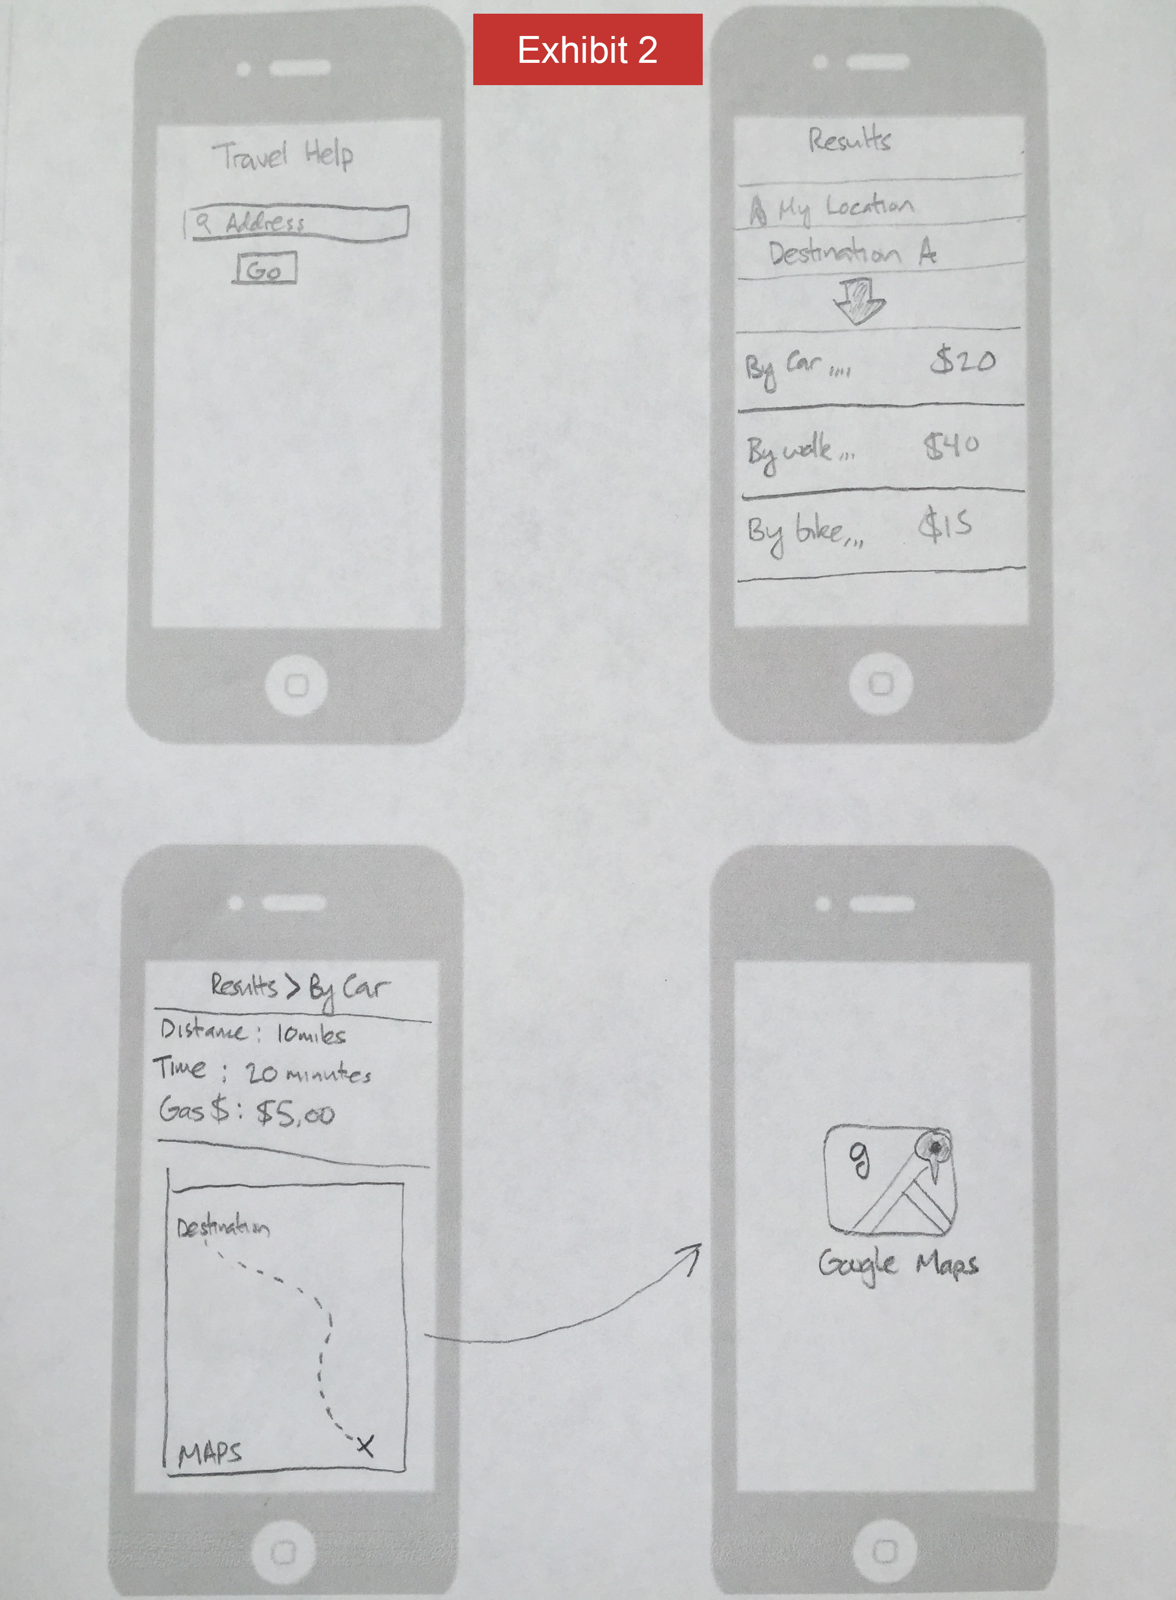
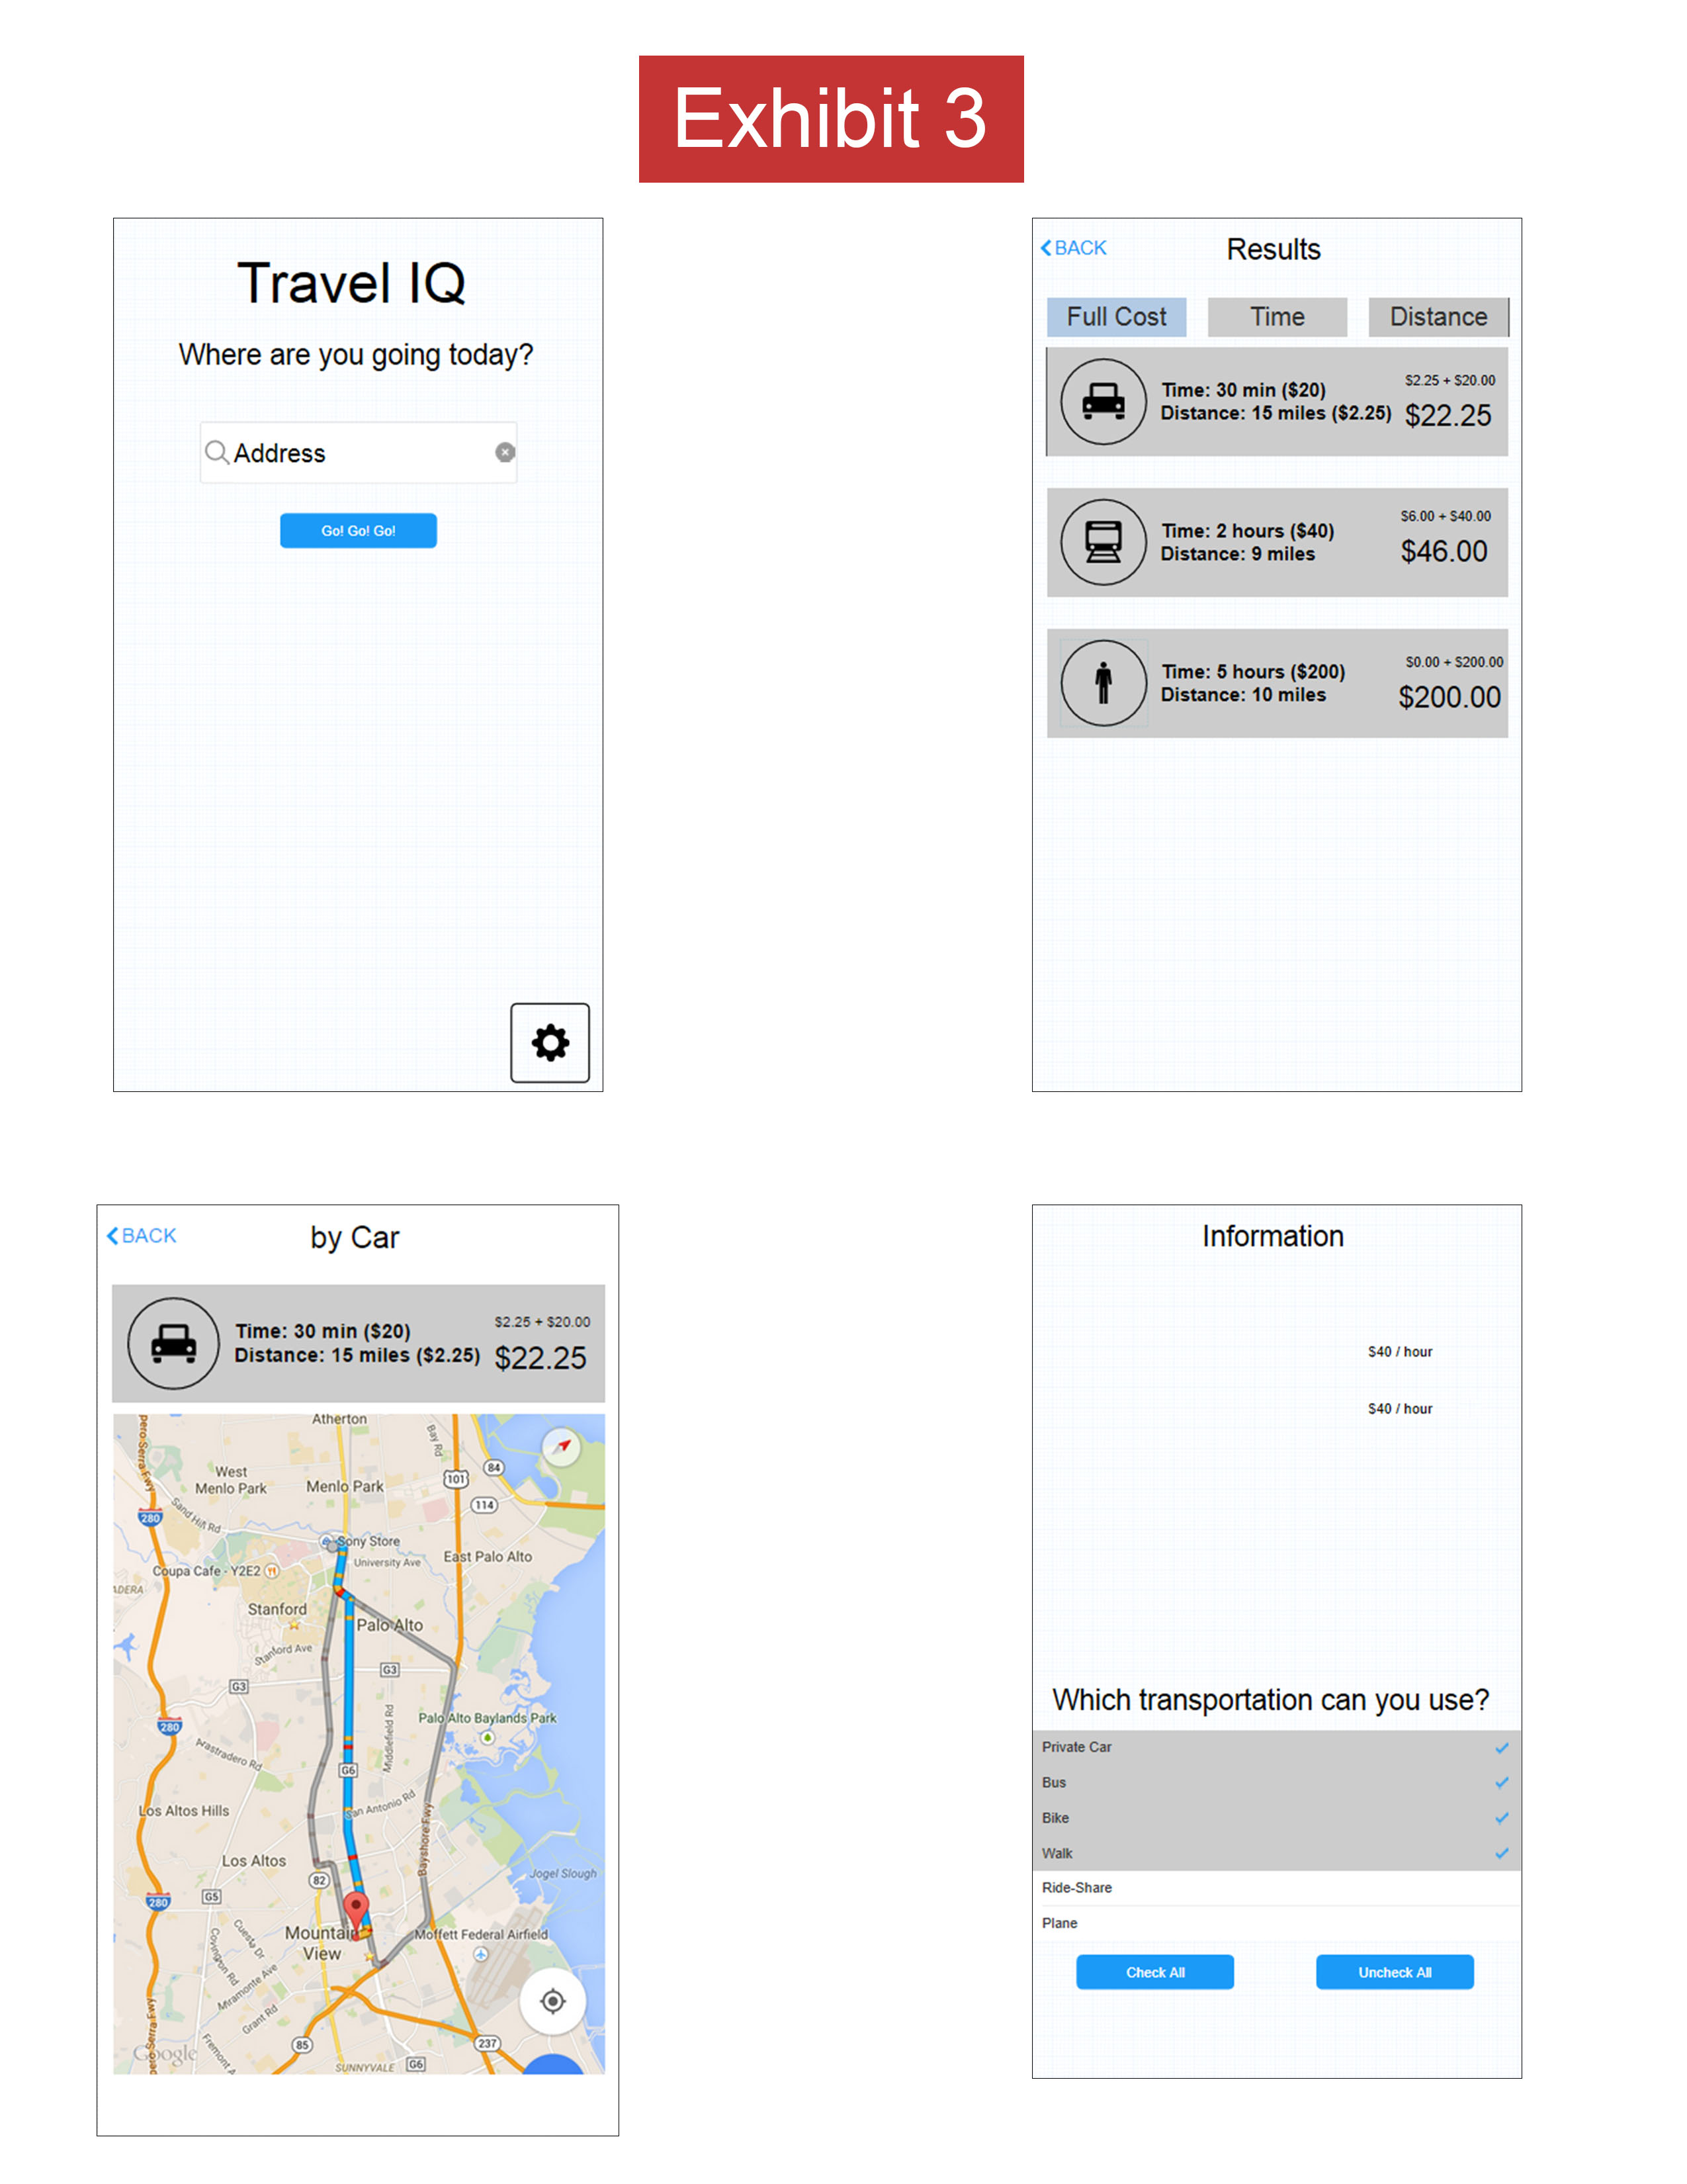

Final App

At the Urban Sustainability Expo, we had a fully developed prototype of the TravelIQ app. Please feel free to give the prototype a go at: https://www.flinto.com/p/abff6c85

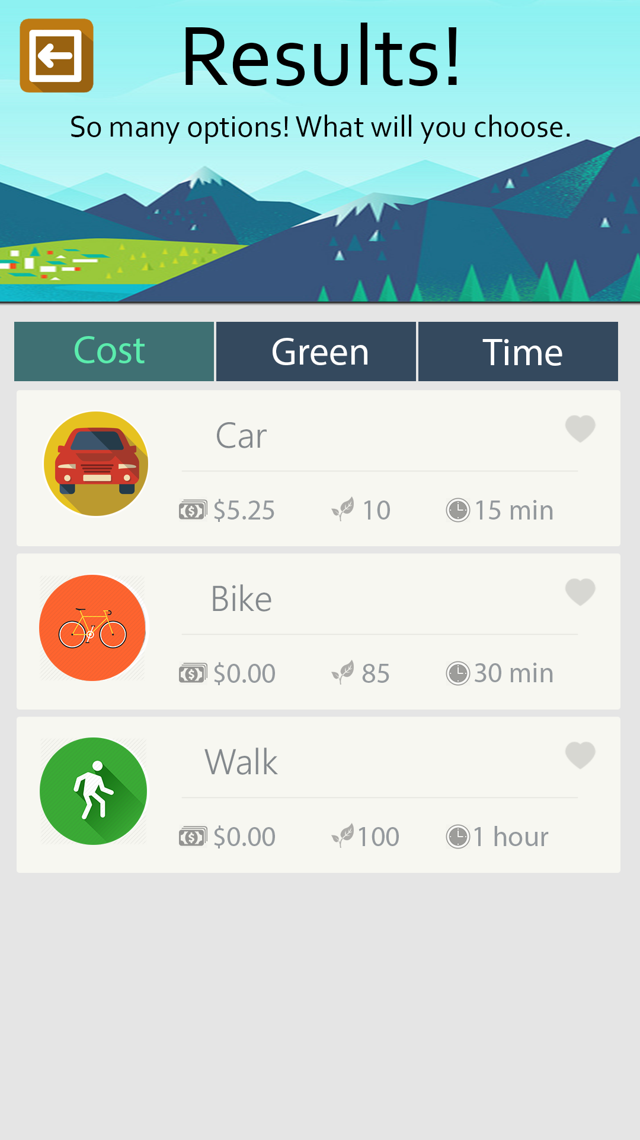

Lego Cityscape

Charging Station
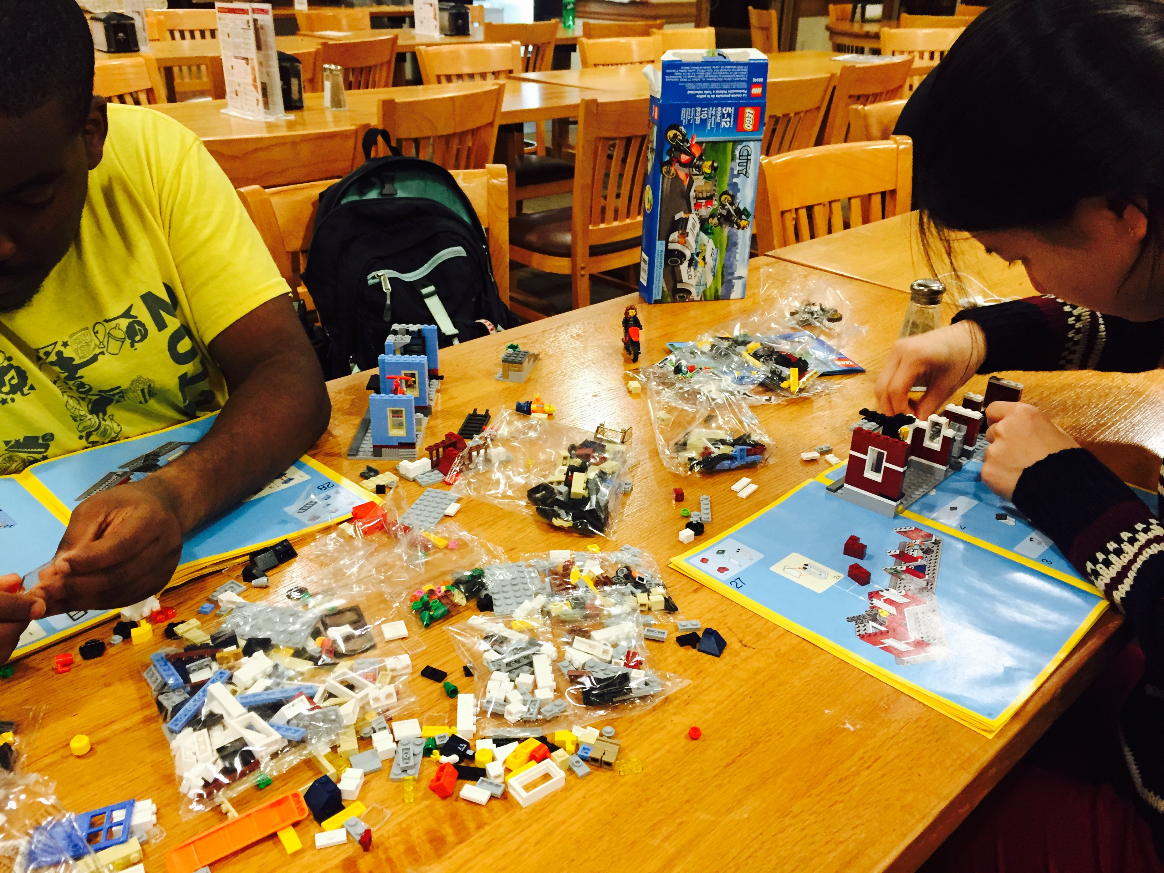

Lego Cityscape under construction. The Lego cityscape is meant to prototype how the new EV charging station would integrate in an urban setting.
There is a large problem in urban China with charging electric bikes. Users either have to bring batteries to their apartment floors or they have to dangle cords precariously outside of windows down to street level. We wanted to explore a new way to charge electric bikes through a central charging station, with the goal of making charging more:
- Simple
- Convenient
- Aesthetically pleasing
- Centralized

In order to explore what this central charging station would look like, we thought it fitting to build a physical model. Legos turned out to be the best physical medium for this.
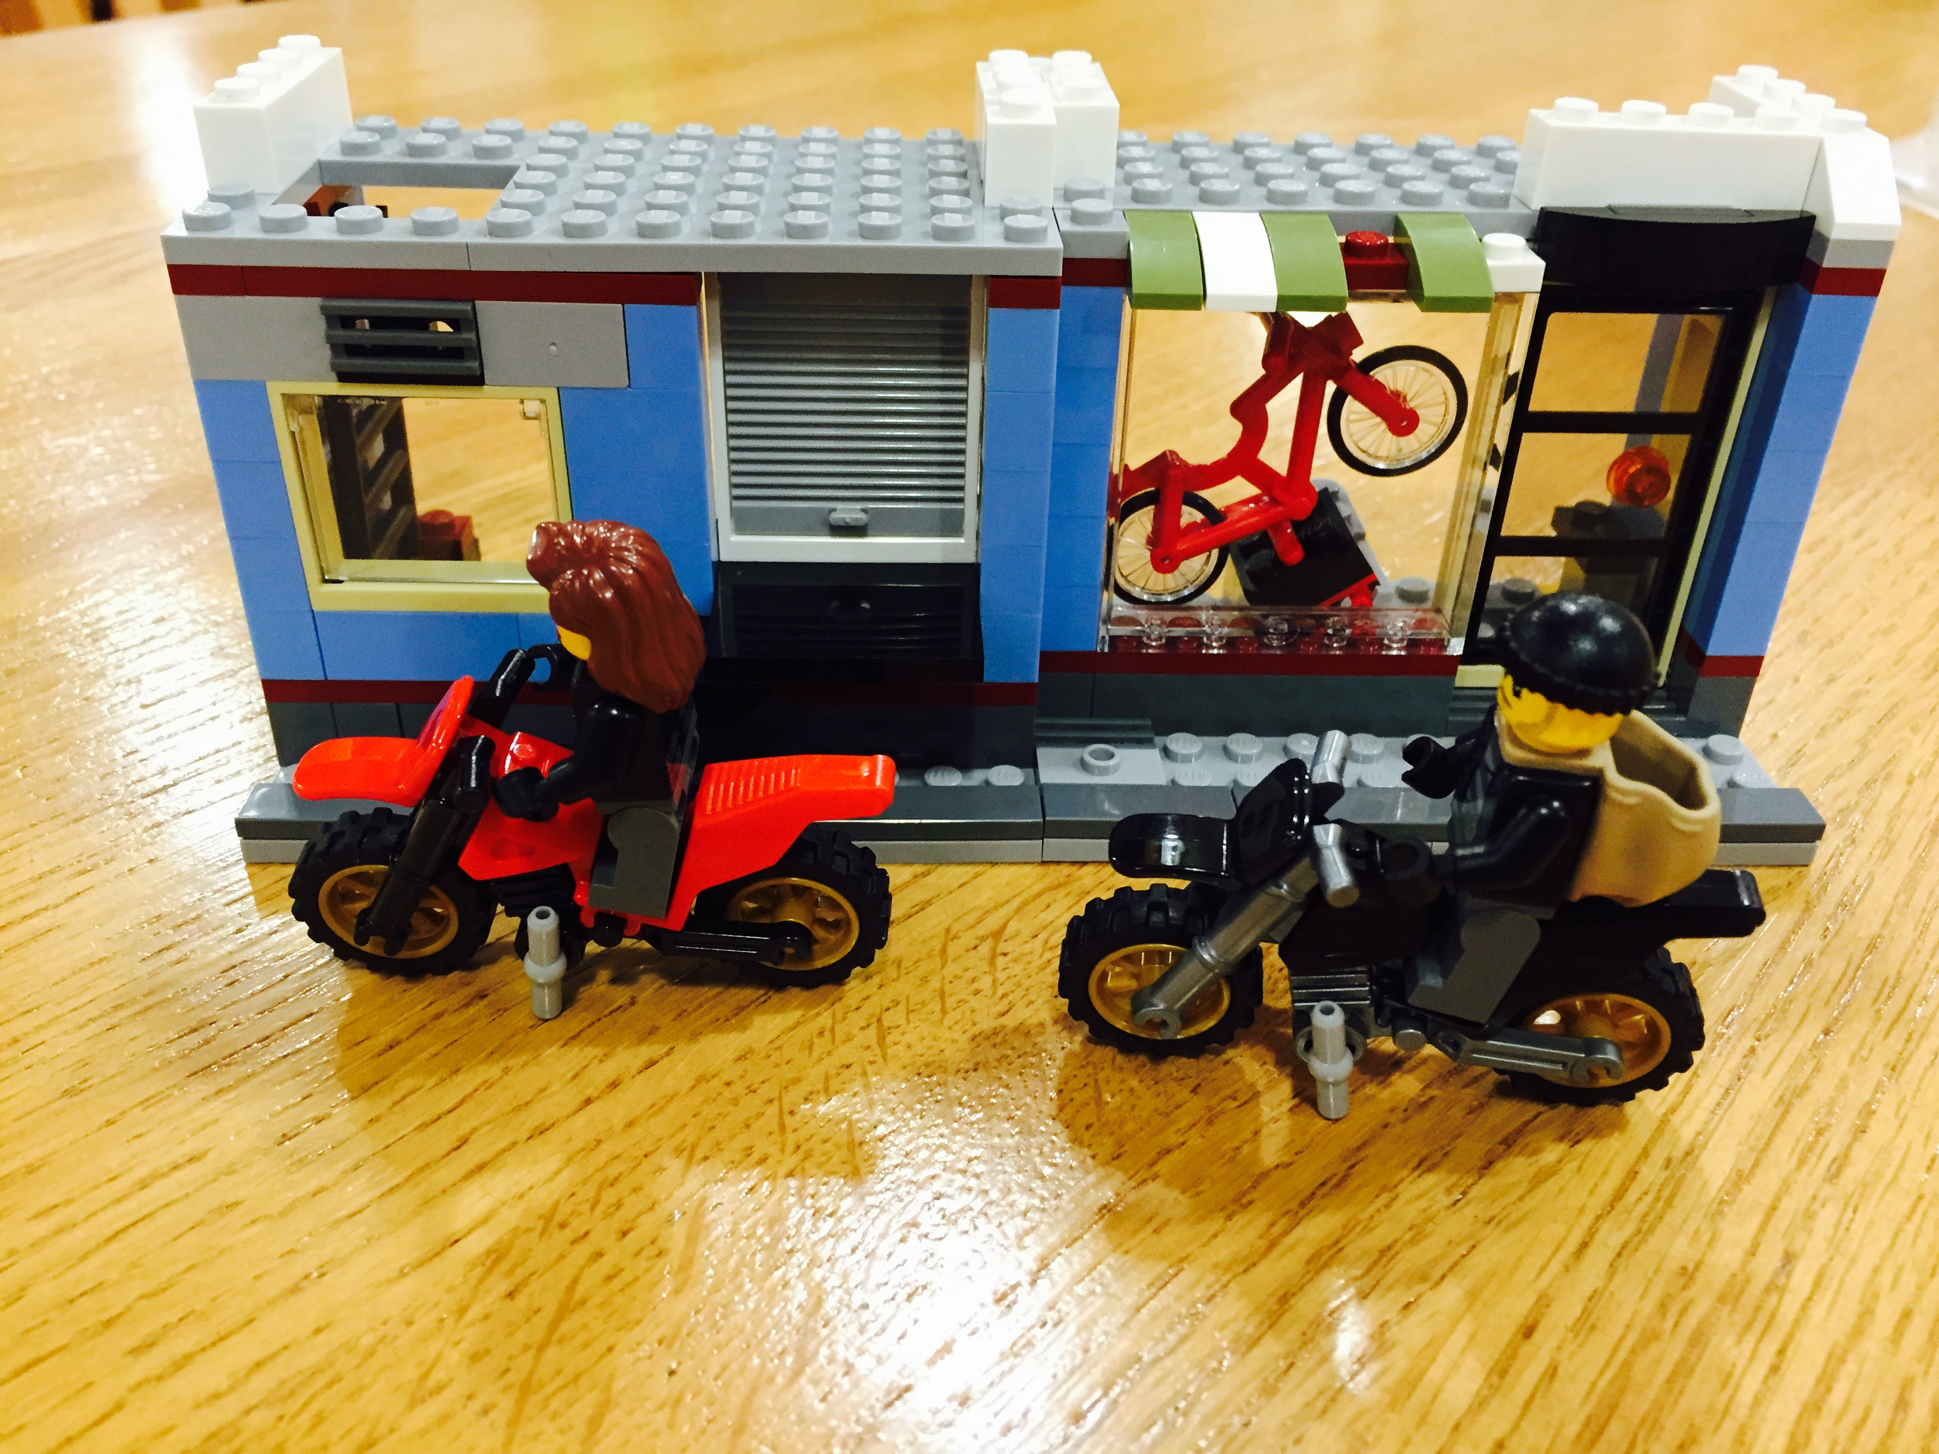

Bikes in front of an urban sidewalk. The prototype showed how bikes and charging stations interact with their urban environment.

TSINGHUA UNIVERSITY – PROTOTYPING
The Future of Electric Bikes – The Tweetie Bike

One of the challenges surrounding electric bikes is that they are optimized in their design for one purpose: transportation. The Tsinghua team sought to look further into this issue by designing a new modern electric bike that could be optimized for all its different functions. An electric bike spends a majority of its time idle and in charging. Limited by their design, the Tsinghua team reimagined the design of electric vehices to make it more convenient to charge, ride, and carry things in.

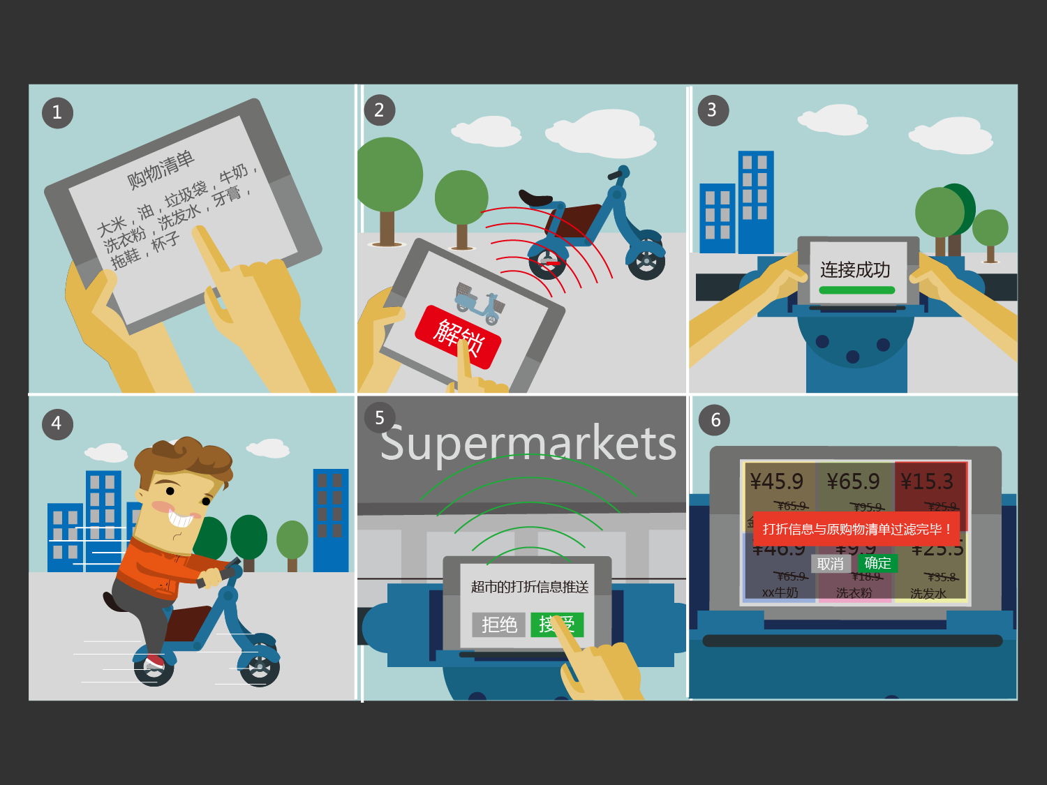
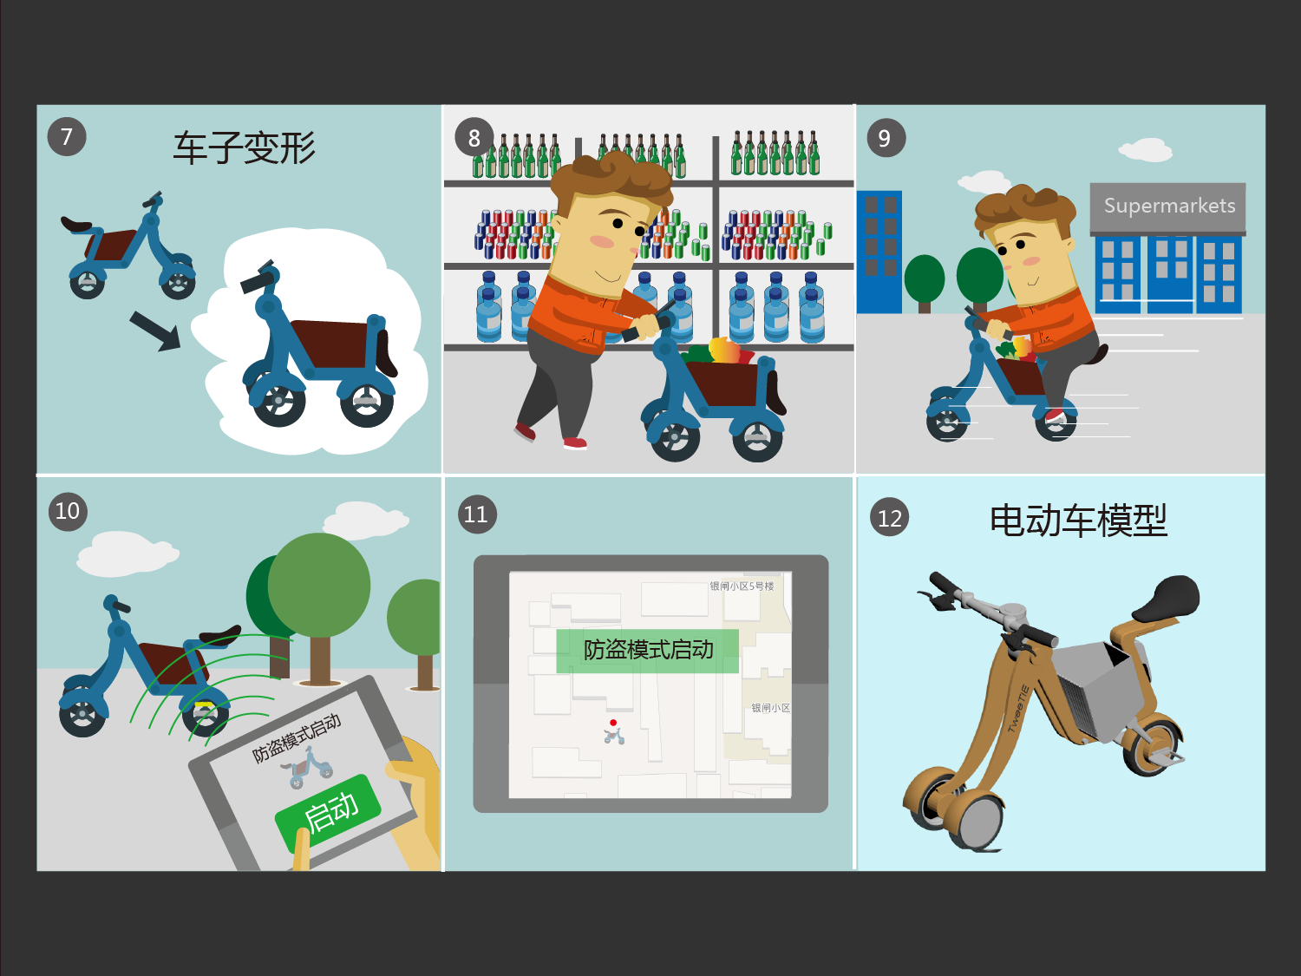

The inspiration behind the Tweetie bike

Using 3D printing and modeling, the team in China designed a bike that had 3 modes:
- Formal Mode
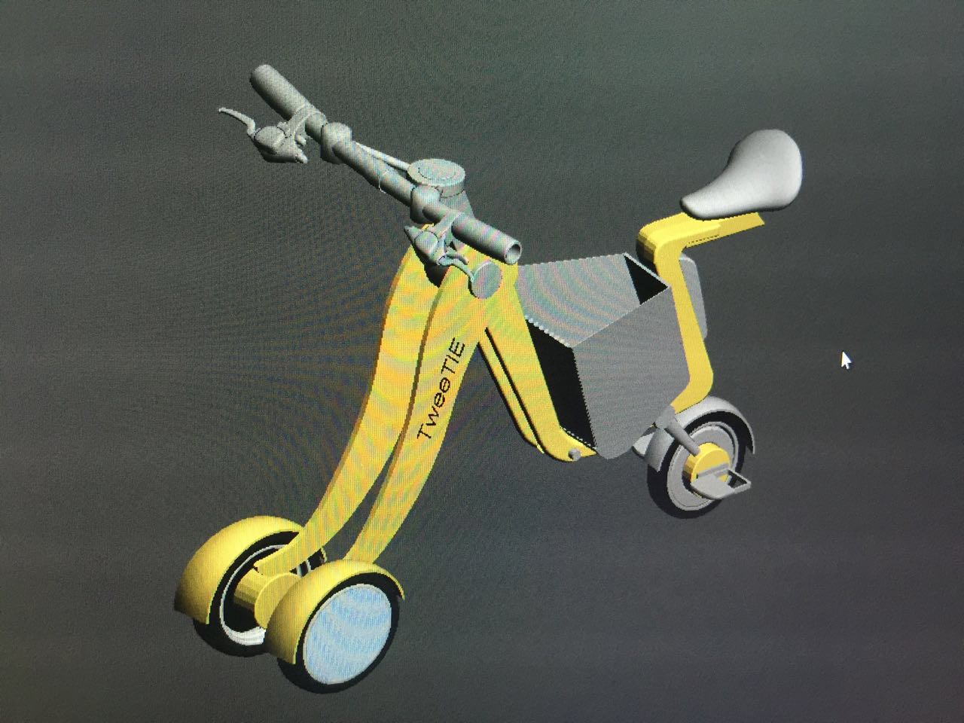
- Market Mode
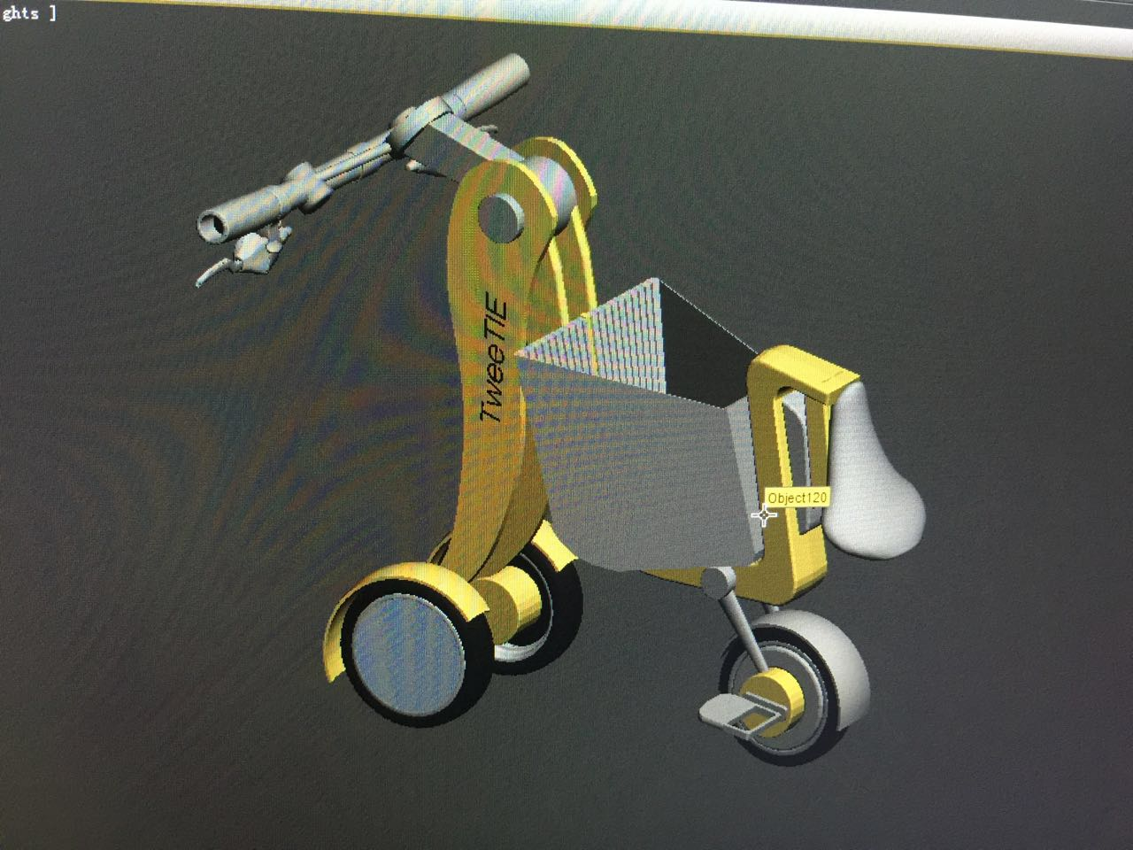
- Storage Mode
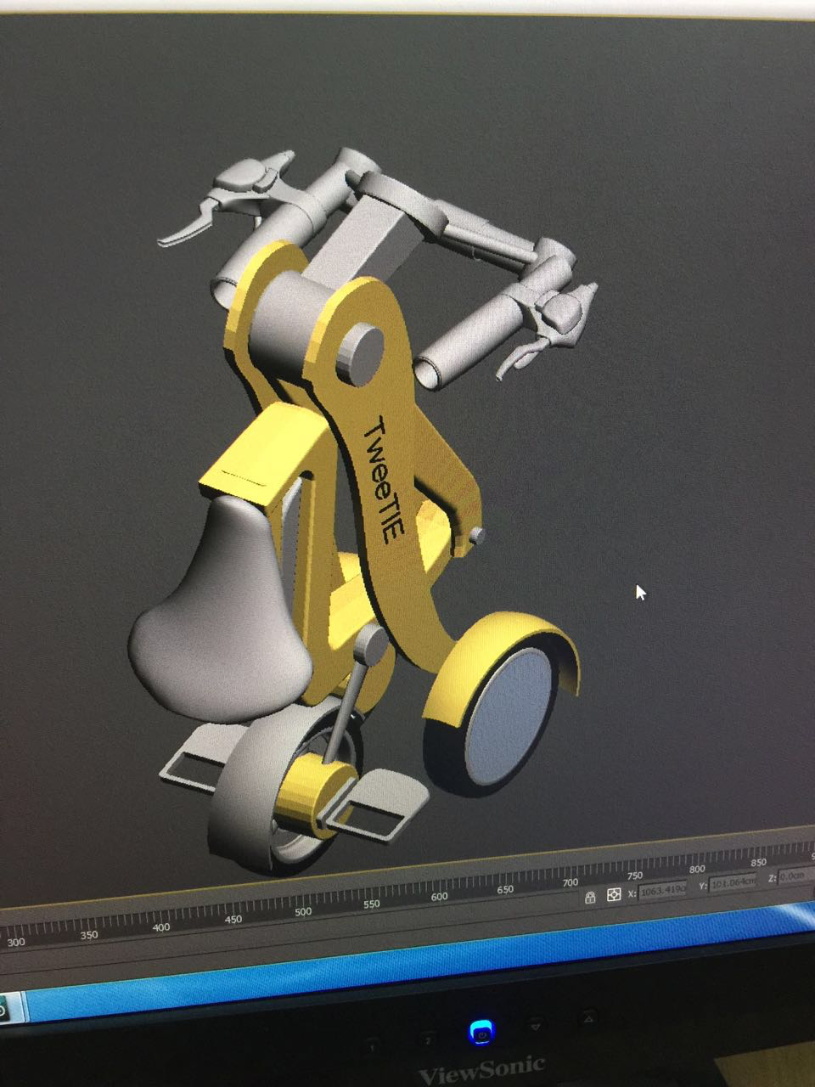
These modes could be set by folding and bending the bike at strategic joints, which makes it incredibly convenient to switch between the different modes. Electric bikes are incredibly heavy and difficult to carry around, especially when they need to be charged. The charging mode puts the bike in a setting that makes it easy to carry and easy to charge. The 3D printed bike was made using a polymer plastic feedstock and was then painted.
3D Printing Process
And just because we think that the process of designing this bike was so intricate, difficult, and incredibly cool, we will show you how this 3D bike was built.
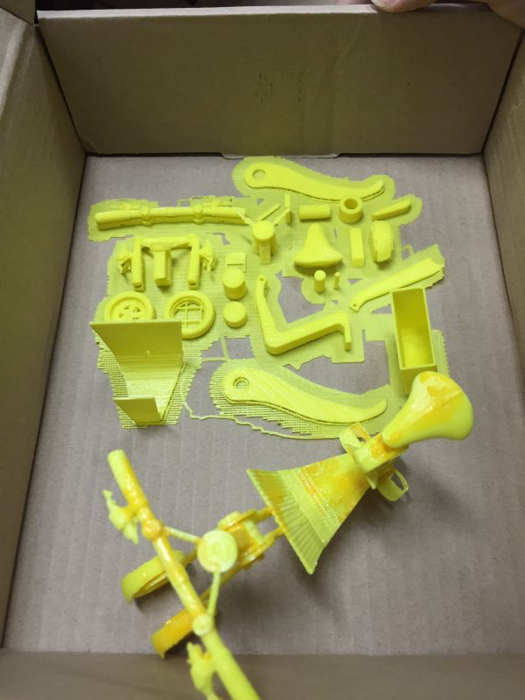
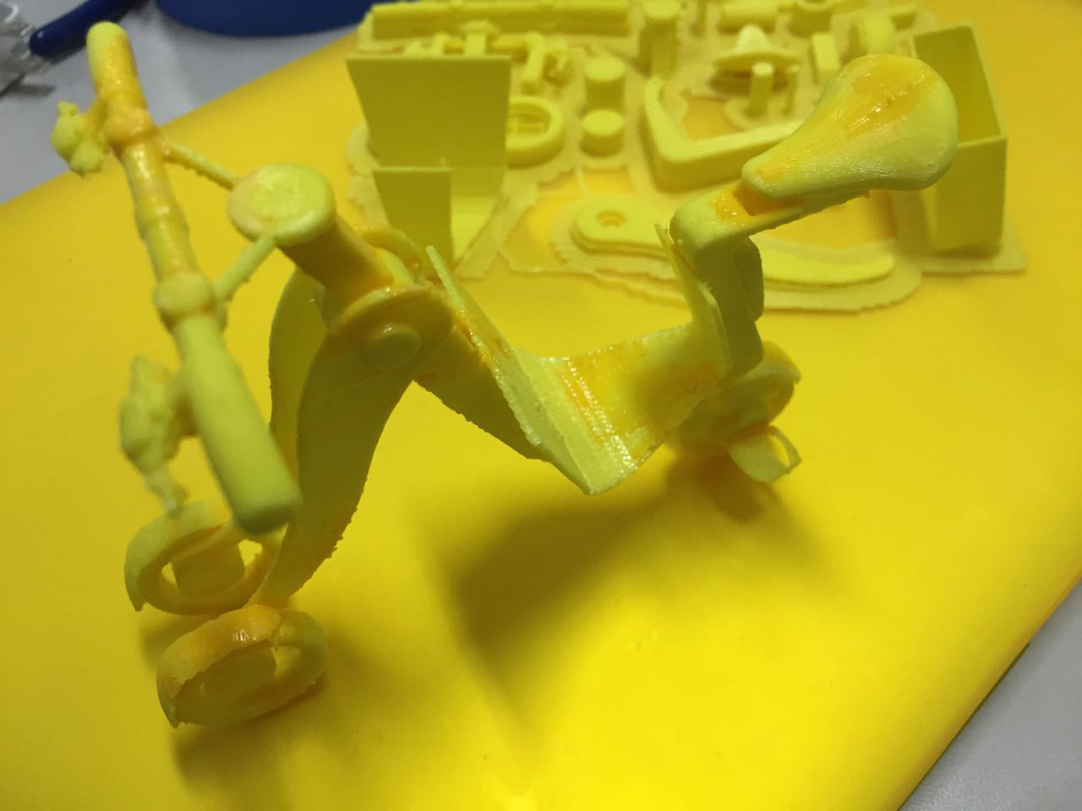

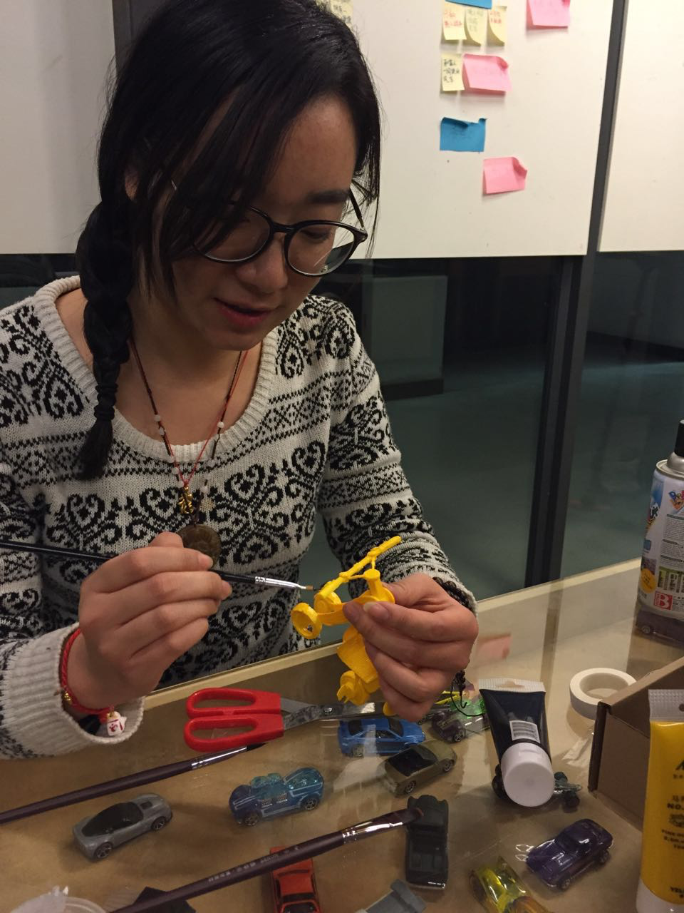
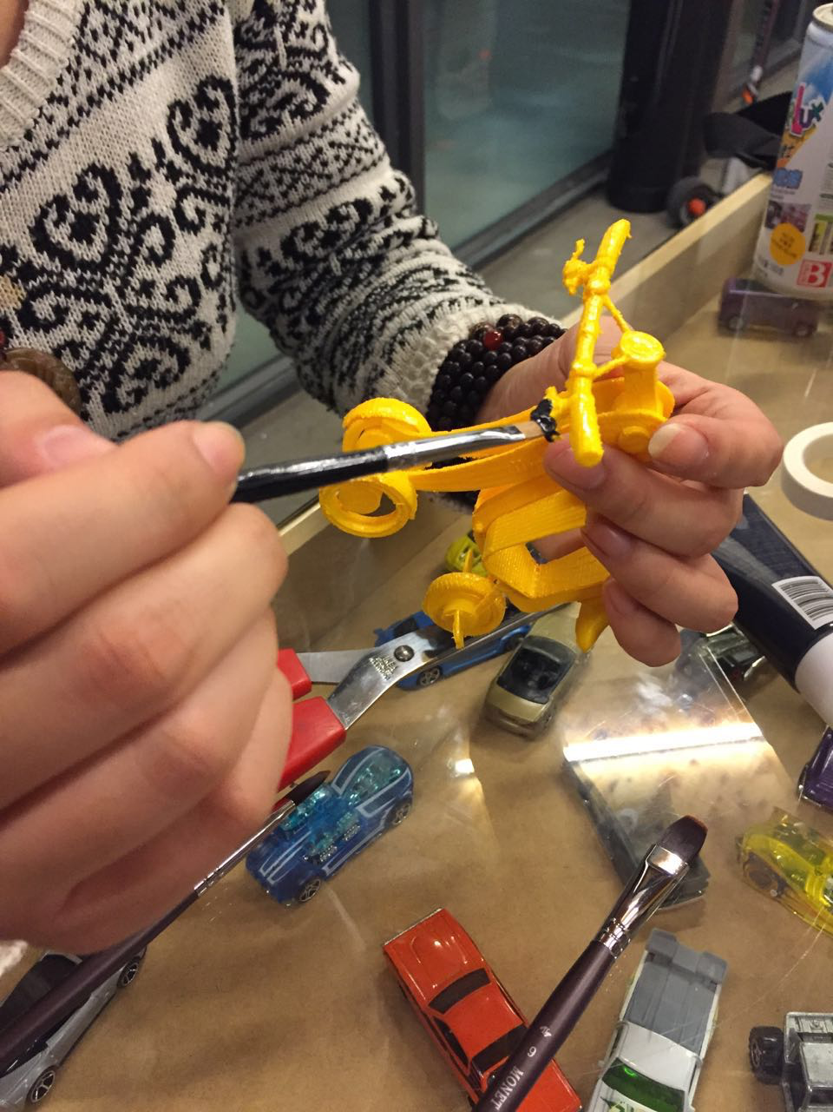

3D Interactive Simulation

The visual design team at Tsinghua then went ahead and put this 3D printed bike in a virtual reality world! We created a 3D simulation of what using our concept bike can feel like. It is a fully interactive simulation. We observe it in various states in the environment in a variety of situations of which it can adapt to. Given the complexity of situations we feel like a interactive simulation was most appropriate to convey the benefits of our prototype. We are confident that this could change the way people think about transportation and start traveling for not only the benefit of themselves, but of the environment.

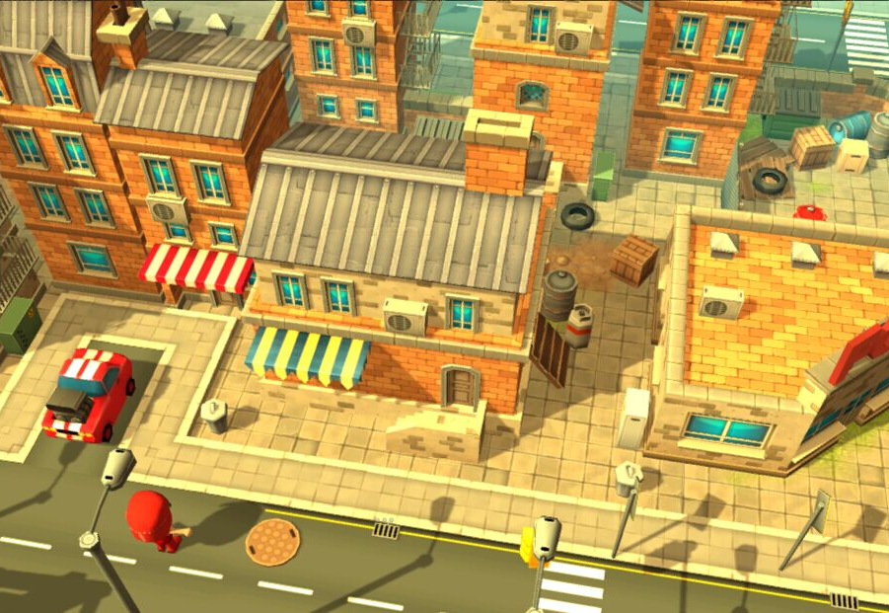
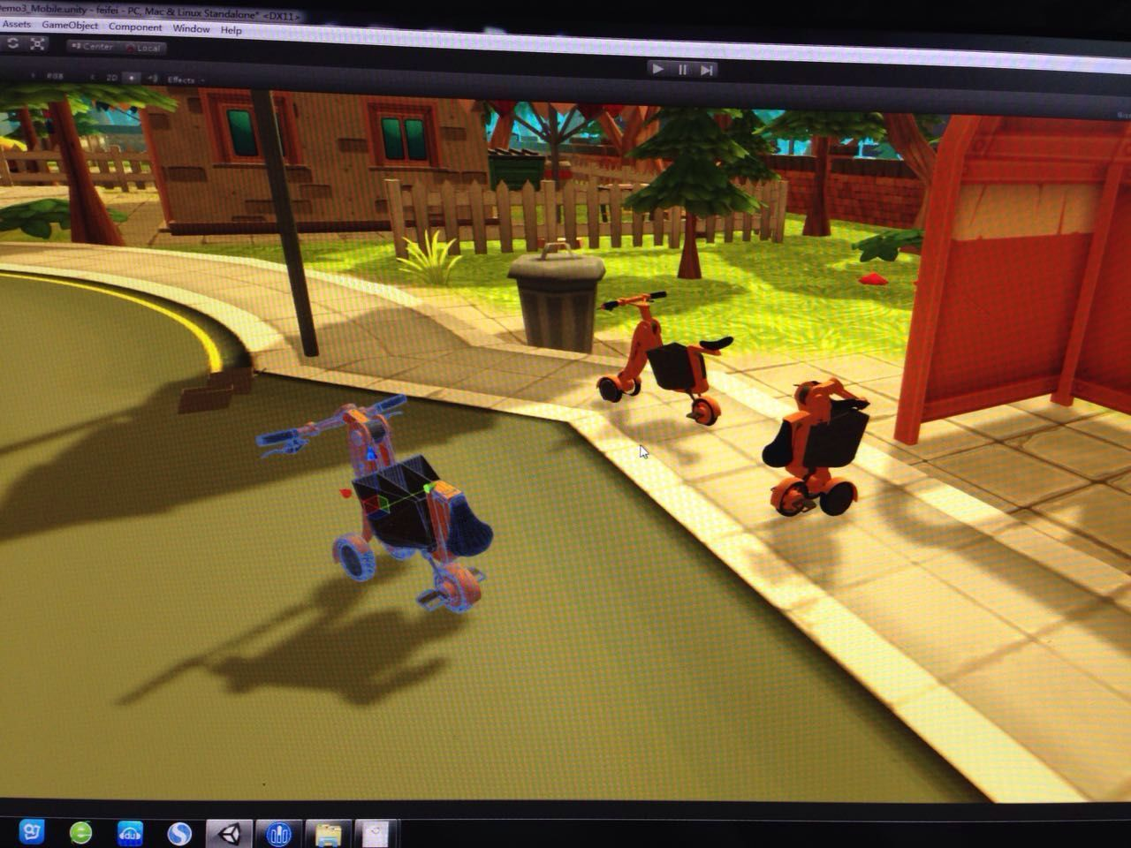

CHINA – TSINGHUA | BAY AREA - STANFORD
The Electric Vehicles team was absolutely thrilled to present our findings at the Urban Sustainability Expo in December 2014. The project taught us a lot about cross-cultural collaboration. Despite language and cultural differences, we showed that it is possible for people to work together half way across the globe. The trip was not without obstacles. There were many times when we felt like we were facing a challenge greater than any of us could handle. But with each other’s support and our close friendship, we put together a product of which we are incredibly proud. This class has been the experience of a life time and has demonstrated that so much can be achieved when we all work together.

